AP Calc AB Name: _______________

______________ _____________

WS Assessment

Target 1:

Intro to limit

**I can:**

* Interpret the rate of change at an instant in terms of average rates of change over intervals containing that instant.
* Represent limits analytically using correct notation.
* Estimate limits of functions

Unit 1: Limits and Continuity

HW Target 1

Unit 1 Progress Check MCQ Part A

 One power of calculus is that it can deal with changes which are infinitesimally small. For example, an average velocity is obtained by taking a distance traveled and dividing by the finite time interval it took to travel that distance. But suppose you wanted the instantaneous velocity at a given instant of time. You can approach that with a "limit", i.e., you can take the smaller distances traveled in shorter intervals and divide by those shorter times. If this process is allowed to continue until the time interval approaches zero, then this is called "taking the limit as the time interval approaches zero".

A rock breaks loose from the top of a tall cliff. What is its average speed (AROC) during the first 2 seconds of fall? And speed at the instant (IROC) t = 2. Hint: Free fall y = 16t2

Average rate of change AROC $\frac{Δy}{Δx}=\frac{16{(2)}^{2}-16{(0)}^{2}}{2-0}$ =

Instantaneous rate of change IROC $\frac{Δy}{Δx}=\frac{16{(2+h)}^{2}-16{(2)}^{2}}{(2+h)-2}$ =

Now you do. What is its average speed during the first 3 seconds of fall? And speed at the instant t = 3.

***We say, the AROC has the limit value IROC. The written symbols for limit $\lim_{x→c}f(x)=L$***

***How do we read it out loud? The limit of f(x) as x approaches c is equal to L***

Given function P(x) = x2 .

Find the slope of the equation of the secant line pass thru (c, P(c)) and (2, P(2)). Write the equation of the secant line

Find the limit of this slope as c 🡪 2, then write the equation of the new line. What is this line called?

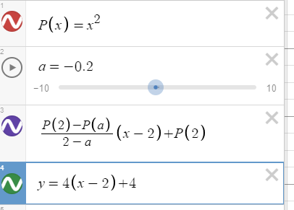

Show illustration by desmos for stamp

We say, as c 🡪 2, the secant line

become a tangent line.

Write and find the limit (*algebraically*) of the following as x approaches to the indicate number

f(x) = 3x – 7, x → 4 h(x) = -5x + 23, x → 2 k(x) = x2 – 9x + 5, x → 3

p(x) = x2 + 3x - 6, x → -1 q(x) = $\frac{x^{2}-4x-12}{x+2}$, x → 2 f(x) = $\frac{2^{x}}{sin(x)}$, x → 3



Write and find the limit of the following as x approaches c

f(x) = x2, x → c f(x) = x2 + 5, x → c f(x) = 4x2, x → c

f(x) = x3 + 4x2 – 3 , x → c f(x) = x → c

For the following, you will find and write the limit of the functions, then use graphing calculator to confirm it.

f(x) = $\frac{(x^{2}-6x+13)(x-2)}{ (x-2)}$, x → 5 g(x) = $\frac{(x^{3}-{8x}^{2}+25x-26)}{(x-2)}$, x → -2

h(x) = $\frac{(x^{3}-{3x}^{2}-4x-30)}{(x-5)}$, x → 2 k(x) = $\frac{(x^{3}-1)}{(x-1)}$, x → -1

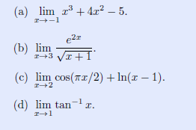

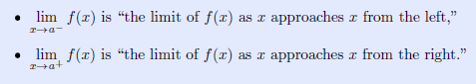

Sometimes it happens that the heights approach one value as x gets close to **a** from the left

has a ***different value*** as x gets close to **a** from the right.

When this happens, we still say that $\lim_{x→a}{f(x)}$ does not exist (DNE)

Find the following limit (*graph*)





Use graph to find the following limit. Draw

$\lim_{x→0}\frac{1}{x^{2}}$ $\lim_{x→0}\frac{|x|}{x}$ $\lim_{x→0}\frac{1}{x}$ $\lim_{x→0} sin⁡(\frac{1}{x})$

The Connection Between Asymptotes and Limits Part

Sketch and explain what happen then identify the asymptote

$\lim_{x→2} f\left(x\right)= ∞$ $\lim_{x→∞} f\left(x\right)= 2$

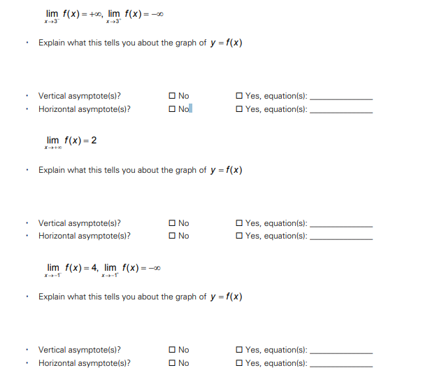

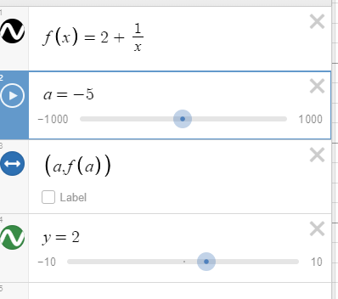Prove the horizontal asymptote of $f(x)=2+\frac{1}{x}$ is the

line y = 2. Show desmos for stamp

There are functions that you can't take limit algebraically, then using tabular method will help.

a. $\lim_{x→1}x^{1/{(x-1)}}=?$ Use 6 decimals number

|  |  |  |  |  |  |  |
| --- | --- | --- | --- | --- | --- | --- |
| 0.9 | 0.99 | 0.999 | 1 | 1.001 | 1.01 | 1.1 |
|  |  |  |  |  |  |  |

b. $\lim_{x→0}\frac{3^{x}-1}{x}=?$ Use 6 decimals number

|  |  |  |  |  |  |  |
| --- | --- | --- | --- | --- | --- | --- |
| -0.1 | -0.01 | -0.001 | 0 | 0.001 | 0.01 | 0.1 |
|  |  |  |  |  |  |  |

c. $\lim_{x→0}\frac{1-cos(x)}{x^{2}}=?$ Radian mode. Use 6 decimals number

|  |  |  |  |  |  |  |
| --- | --- | --- | --- | --- | --- | --- |
| -0.1 | -0.01 | -0.001 | 0 | 0.001 | 0.01 | 0.1 |
|  |  |  |  |  |  |  |

d. $\lim_{x→0}\frac{tan(2x)}{5x}=?$ Radian mode. Use 6 decimals number

|  |  |  |  |  |  |  |
| --- | --- | --- | --- | --- | --- | --- |
| -0.1 | -0.01 | -0.001 | 0 | 0.001 | 0.01 | 0.1 |
|  |  |  |  |  |  |  |

Using table find the following limit

$\lim_{x→-3}\frac{x^{2}-9}{x+3}$ $\lim_{x→0}(1{+x)}^{1/x}$

Given 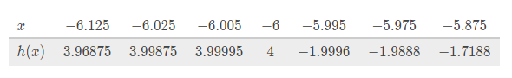

Find $\lim_{x→{-6}^{-}}{h(x)}$ $\lim_{x→{-6}^{+}}{h(x)}$ $\lim_{x→-6}{h(x)}$

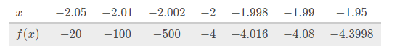

Find $\lim_{x→{-2}^{-}}f{(x)}$ $\lim_{x→{-2}^{+}}{f(x)}$ $\lim_{x→-2}{f(x)}$

Assessment

Find the slope of the line tangent to the graph of g(x) = - x2 + 2x - 1 at the point (2,-1). Show desmos proof for stamp. Hint: Find slope thru (c, g(x)) and (2, -1)

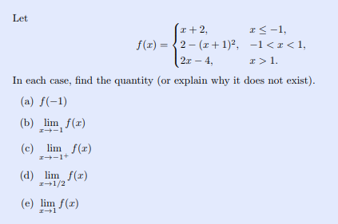

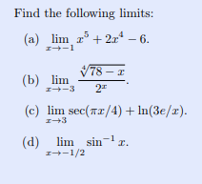





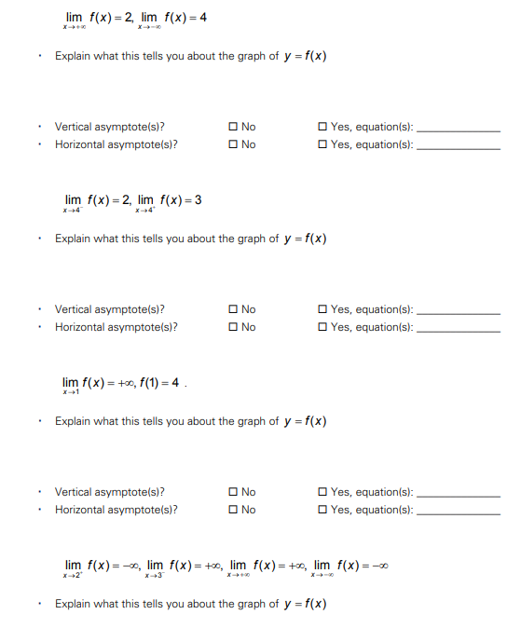

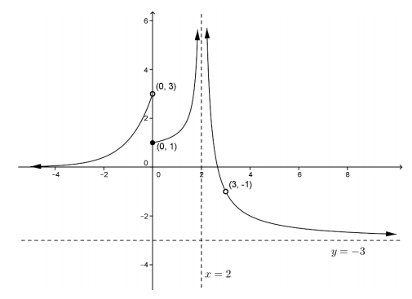Given graph of a function f(x) . There are eleven limit statements, including one-sided and two-sided limits, based on the labeled points and lines on this graph. Write at least ten of these limit statements.